Dataset
rnd_room_c2_06: HEAD tilt: -0.4
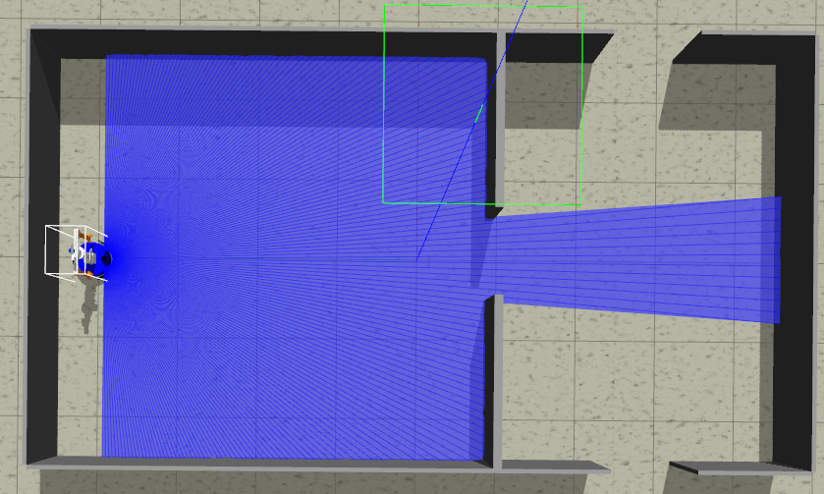
samples
1)
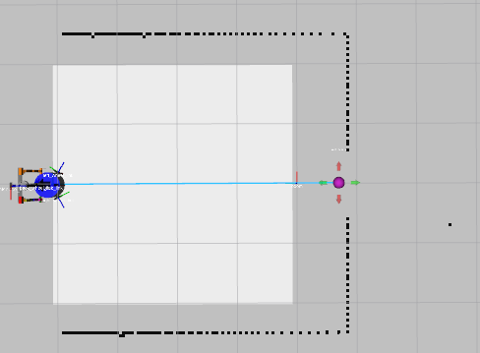
linea recta a puerta 4.8m (x3) (0.0 4.1 -1.57075) to (0.0, -0.7)
files: data_from_path_2025-02-27_11-19-00 to data_from_path_2025-02-27_11-19-41

2)
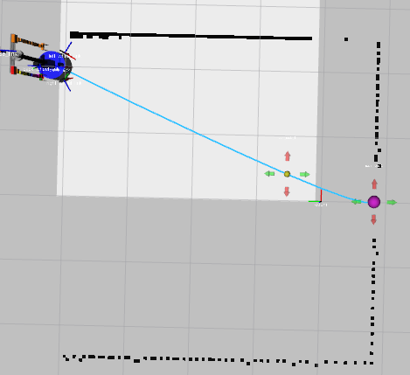
esq inf izq a puerta 5.2m (x3) (2.0 4.1 -1.57075) to (0.0, -0.7)
files: data_from_path_2025-02-27_11-22-26 to data_from_path_2025-02-27_11-23-24

3)
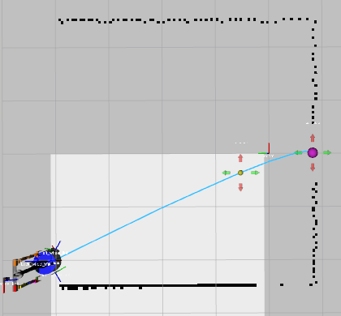
esq inf der a puerta 5.3m (x2) (-2.0 4.1 -1.57075) to (0.0, -0.7)
files: data_from_path_2025-02-27_11-27-15 to data_from_path_2025-02-27_11-27-56

4)
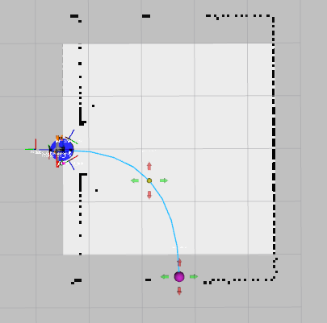
puerta a puerta der 3.2m (x4) (0 -0.5 1.57075) to (-2.4, -2.7)
files: data_from_path_2025-02-27_11-34-57 to data_from_path_2025-02-27_11-36-24

5)
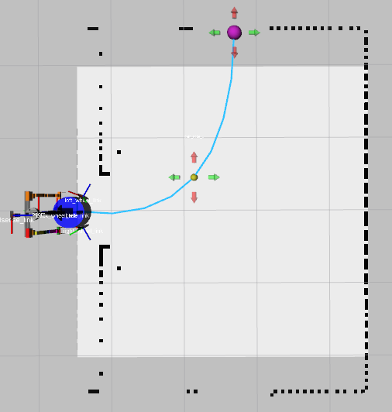
puerta a puerta izq 3.2m (x4) (0 -0.5 1.57075) to (2.4, -2.7)
files: data_from_path_2025-02-27_11-39-34 to data_from_path_2025-02-27_11-40-23

6)
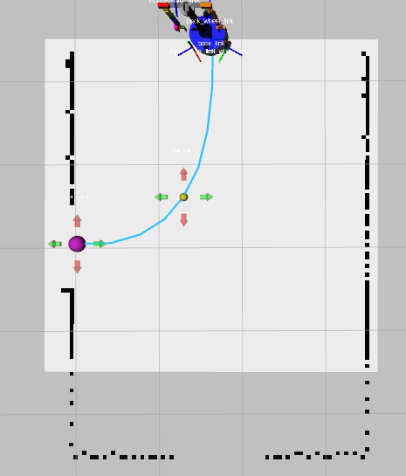
puerta a puerta der 3.0m (x4) (2.6 -2.7 PI) to (0.0, -1.0)
files: data_from_path_2025-02-27_11-45-48 to data_from_path_2025-02-27_11-46-42

7)
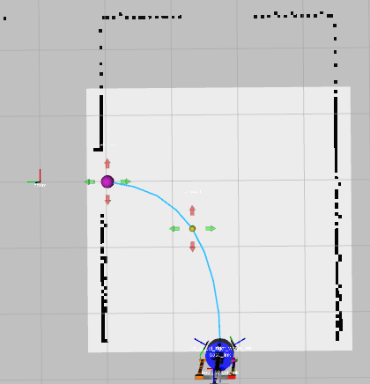
puerta a puerta izq 3.0m (x4) (-2.6 -2.7 0) to (0.0, -1.0)
files: data_from_path_2025-02-27_11-49-46 to data_from_path_2025-02-27_11-50-31

8)
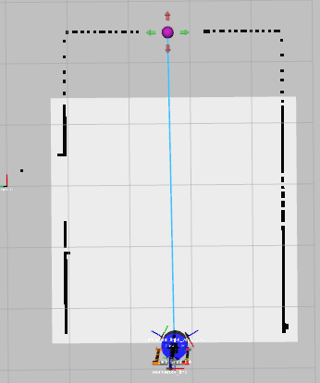
recta puerta der a puerta izq 5.2m (x4) (-2.6 -2.7 0) to (2.6, -2.7)
files: data_from_path_2025-02-27_11-55-30 to data_from_path_2025-02-27_11-56-24

9)
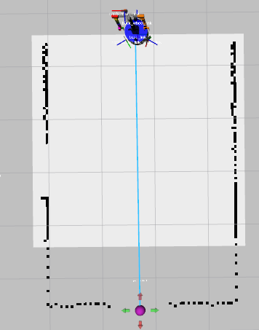
recta puerta izq a puerta der 5.2m (x4) (2.6 -2.7 PI) to (-2.6, -2.7)
files: data_from_path_2025-02-27_11-59-16 to data_from_path_2025-02-27_12-00-07

-----
NO Mirror
-----

